4237578 - Make note dialogs larger
Make note dialogs larger (Epic 4237578)1. Customer Problemnote dialogs hamper reading and editing long content.
2. Customer Researchexpand Add, Edit, and Reply dialogs with context-appropriate sizes.
3. Our SolutionLarger, resizable dialogs with responsive layout.
- Persisted size preference; keyboard shortcuts remain.
Dependencies: FE dialog components, add-in UI.
4. Product MetricsScroll actions per note edit: -40%.
- User satisfaction (dialogs): +10 pts.
Appendix: Child Features4237579 Enhanced Notes List Screen Dialogs
- 4237581 Add-in Note Dialog Enhancement
Appendix: LinksHYPERLINK "https://dev.azure.com/tr-tax/TaxProf/_workitems/edit/4237578"Open Epic 4237578

Appendix: Quick prototype
Figure: PDF page 1
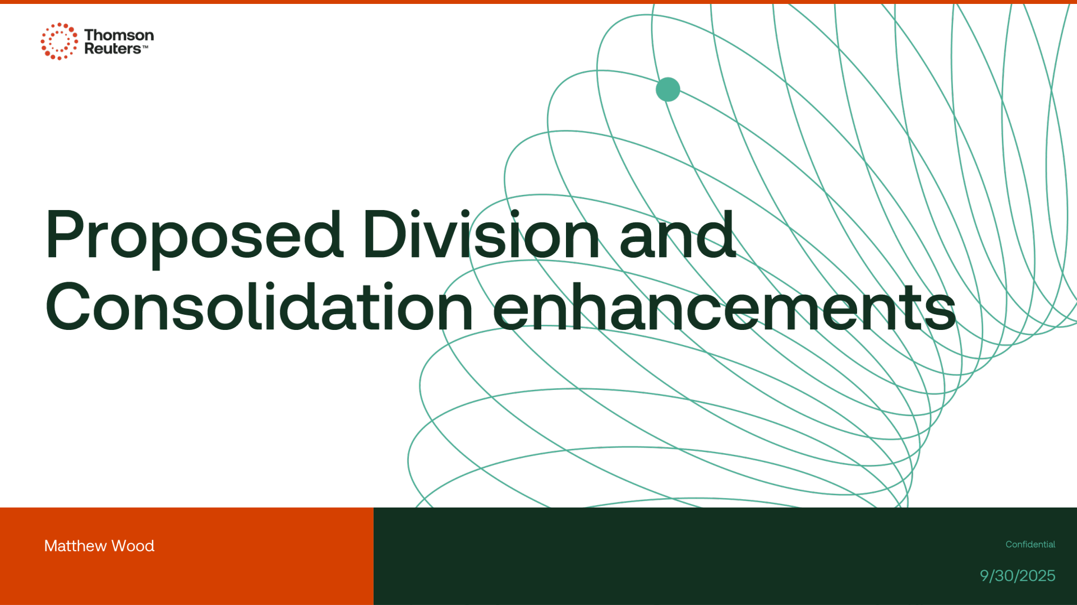

Appendix: Links
ADO Epic Link: https://dev.azure.com/tr-tax/TaxProf/_workitems/edit/4237578

